UNIT 9
I’m not feeling well

Target Skills  (Keterampilan Utama) | Speaking and Writing (Berbicara and menulis)
Supporting Skills  (Keterampilan Pendukung) | Listening and reading (Mendengar dan membaca)
Learning Objectives  (Tujuan Pembelajaran) | You will be able to: (Anda akan mampu melakukan hal-hal berikut)  - Identify parts of the body  - Identify different types of illness  - Perform a dialog at the doctor’s office
Learning Activities  (Kegiatan Pembelajaran) | - Start:  - Parts of the body  - Types of illnesses  - Master:  - Model Dialog  - Comprehending the dialog  - Apply: A conversation at the doctor’s office  - Guided role play  - On your own  - Review:  - Interviewing a friend  - Take note: Drinks to consume during cold and flu infection

Let’s Start
Activity 9.1. Identifying Parts of the Body
Label the different parts of the body with the words below.
- Hand
- Foot
- Head
- Elbow
- Stomach
- Leg
- Arm
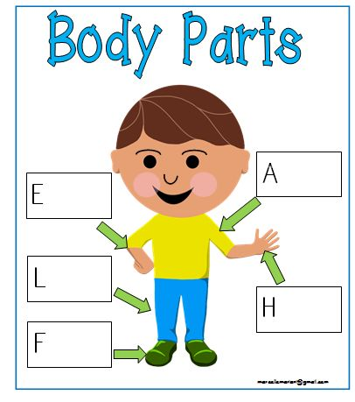
6
7.
5
4
3
2

Activity 9.2. Common Illnesses
Match the common illnesses and the pictures. (Pasangkan berbagai jenis penyakit umum dengan gambar terkait).
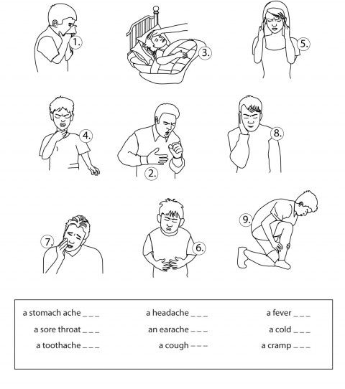
Let’s Master it
Activity 9.3. Answering questions about the Model Dialog
Situation: Sharon is at the doctor’s office. (Sharon pergi ke dokter).
Read the dialog and answer the questions. (Bacalah dialog dan jawab pertanyaan di bawahnya).
Sharon | : | Good afternoon, Doctor.
Doctor | : | Good afternoon. Please have a seat.
Sharon | : | Thank you, doctor.
Doctor | : | So, you are Sharon Smith?
Sharon | : | Yes, doctor.
Doctor | : | What seems to be the problem, Sharon?
Sharon | : | Well, I have a bad cough and a sore throat.
Doctor | : | Do you also have a headache?
Sharon | : | Yes, I do.
Doctor | : | How long have you had these symptoms?
Sharon | : | About three days. It’s really bothering me. What’s wrong with me, doctor?
Doctor | : | Well. Let me do an examination on you first. Why don’t you lie down over here?
Sharon | : | Okay, doctor.
Doctor | : | (After the observation).  It seems that you’ve got the flu.
Sharon | : | So, what should I do doctor?
Doctor | : | Take aspirin every four hours and get plenty of rest. Make sure you drink lots of fluids.  Here is the prescription to get the medicine.
Sharon | : | Thank you, doctor.
Doctor | : | You’re welcome. Get well soon.

Questions about the dialog.
- Where is Sharon now?
- What are the symptoms she is experiencing?
- How long has she had the symptoms?
- According to the doctor, what is Sharon’s illness?
- What does the doctor recommend Sharon to do?
Language expressions at the doctor’s office
NO | DOCTOR | PATIENT
1. | Asking what the health problem is:  - What seems to be the problem?  - What’s the matter?  - How are you feeling today? | Describe the health problem:  - I have a headache.  a rash on my arm.  a bad cold.  a stomachache.
2. | Asking the duration of the problem:  - How long have you had the …. (headache, rash, stomachache, etc.)  - How long have you had these symptoms? | - It’s been about a week.  - I have had it for about three days.  - About ___ days.
3. | Asking if the patient has any other problems:  - Have you had any other problems?  - Do you have any allergies? | Yes. I’ve got ___ (a headache and diarrhea).  No, I don’t think so.  Yes, I’m allergic to …
4. | Examining the patient:  - Well. Let me do an observation on you.  - Please lie down over here.  - Please open your mouth.  - Let me see your arm. | Okay, doctor.
5 | Asking for prior medication  - Did you take any medicine for it? | I took aspirin for two days, but it didn’t seem to help.
5 | Giving prescription:  - I’m going to give you a prescription for medication for your ____ (flu, rash, headache)  - Please take it ___ times a day. | Thank you, doctor.
6. | Giving advice:  - Please drink a lot of water.  - You need to ____  - You should _____ | All right, doctor. Thank you.

Let’s Apply
Activity 9.4. Choosing the right language expressions
Choose the best language expression in each number. (Pilih ungkapan yang paling tepat digunakan di tiap nomor di bawah ini)
Dialog 1
Doctor : Good evening. Come on in and have a seat.
Patient : Thank you, doctor.
Doctor : So, 1. (a) How are you?
(b) What seems to be the problem?
(c) Are you okay?
Patient : I have a rash on my left arm.

Dialog 2
Doctor : 2. (a) Can you tell me where your left arm is?
(b) Can you help me with your left arm?
(c) Can I see your left arm?
Patient : Here it is doctor.
Doctor : 3. (a) How are you feeling now?
(b) How long have you had the rash?
(c) Where do you have the rash?
Patient : About three days.

Dialog 3
Doctor : 4. (a) Did you take any medicine for it?
(b) Did you know any medicine for it?
(c) Did you know what medicine to use?
Patient : I put some cream on it, but it didn’t seem to help.
Doctor : I will give you 5. (a) an advice for your rash.
(b) a suggestion
(c) a prescription
It’s an ointment.
Patient : Okay, doctor. 6. (a) How often should I apply it?
(b) How long should I apply it?
(c) How should I apply it?
Doctor : Please apply it three times a day.
Activity 9.5. Role Play
Use the following situations to act out a dialog with your partner. (Pilihlah salah satu situasi di bawah ini untuk).
Situation 1  Patient  - Ailment: Flu  - Duration: Two days  - Previous Medication: You took some aspirin.  Doctor  - Prescribe: antiviral medication. Take three times daily after meals.  - Advice:  - Get a lot of rest.  - Drink plenty of fluids. | Situation 2  Patient  - Ailment: Sore Throat  - Duration: Three days  - Previous Medication: You have been taking some throat lozenges (throat candies).  Doctor  - Prescribe: some medication  Take every four hours.  - Advice:  - Drink plenty of liquids.  - Drink warm tea with honey. | Situation 3  Patient  Ailment: A rash on your arms  Duration: Four days  Previous Medication: You have put a cream on it.  Doctor  - Prescribe: an ointment.  Apply four times a day.  - Advice:  (a) Avoid scratching your skin.  (b) Use as little soap as possible.
Situation 4  Patient  - Ailment: Diarrhea  - Duration: Three days  - Previous Medication: You have taken some pills that you bought at the drugstore, but they didn’t help.  Doctor  - Prescribe: some medicine  Take twice daily.  - Advice:  (a) Drink plenty of fluids.  (b) Avoid foods containing  milk | Situation 5  Patient  - Ailment: A cut  - Duration: Since this morning.  - Previous Medication: None.  Doctor  - Prescribe: an antibacterial ointment. Apply three times daily.  - Advice:  - Wash carefully with mild soap.  - Keep dirt out of it. | Situation 6  Patient  - Ailment: sprained ankle  - Duration: since yesterday.  - Previous Medication: You took a painkiller.  Doctor  - Prescribe: some pain killers  Take whenever you have pain. (maximum five times daily)  - Advice:  - Keep your foot elevated.  - Keep ice on it for 24 hours.

Let’s Review
Activity 9.5. Reflective questions
Please discuss the following questions. Answer the questions for yourself first, then, interview a friend to complete the information under ‘Your friend’. (Diskusikan pertanyaan berikut dengan teman di kiri/kanan anda. Jawablah pertanyaan-pertanyaan berikut lalu interview teman anda untuk melengkapi informasi dibawah kolom “Teman Anda”).
No | Questions | You | Your friend
1 | What do you do to keep fit? (Explain briefly)  - Exercise at home?  - Jogging, walking?  - Going up and down the stairs?  - Others?
2 | What do you consume to keep fit? (Explain briefly)  - Vitamins?  - Fruits?  - Vegetables?  - Healthy drinks?

Let’s Take Note
Activity 9.6. Discussion Questions
Read the article and answer the questions. Then, discuss the answers with other students. (Bacalah artikel di bawah ini, dan jawab pertanyaan-pertanyaannya. Lalu, diskusikan jawaban anda dengan yang lain).
WHAT TO DRINK DURING COLD AND FLU INFECTION
According to an article posted on Virtual Medical Center website, drinking plenty of fluids is highly recommended during cold and flu infection. During this type of infection, your body loses a lot of water. That is why you need fluids to speed up the process of recovery. The fluid that you consume can help loosen mucus in your nose and relieve congestion. Drinking a lot of fluids can also make your body stay hydrated in order to function well and defend itself against the germs.
How much fluid do you have to consume?
The article recommends a person suffering from cold and flu infection to drink a minimum of 250 ml cups of fluid each day.
And what do we drink during this type of ailment?
The recommended type of fluid to drink is water. Water can help lubricate the mucous membranes of the throat. Hot drink is also a good choice to consume. Other types of drink that are recommended are honey and lemon tea, and ginger tea.
What not to drink during cold and flu infection?
However, there are some types of fluid that are not recommended to consume during cold and flu infection. These types include: Alcoholic drinks and caffeinated drinks like coffee, cola drinks, and energy drinks because they can cause dehydration.
(Source: Cold and Flu: What to eat and drink to get better faster, Virtual Medical Center, www.myvmc.com)
Questions about the article:
- According to the article, how much fluid do we need to drink daily?
- What types of drink are recommended by the article?
- What types of drink are not recommended to consume during cold and flu infection?
Questions about you:
- Do you drink a lot of fluid during cold and flu infection?
- What types of drink do you consume during cold and flu infection?
- What else do you consume to get better faster?

