UNIT 4
Let’s Go Groceries Shopping: Food and Drink
Target Skills  (Keterampilan Utama) | Speaking and Writing (Berbicara and menulis)
Supporting Skills  (Keterampilan Pendukung) | Listening and reading (Mendengar dan membaca)
Learning Objectives  (Tujuan Pembelajaran) | You will be able to: (Anda akan mampu melakukan hal-hal berikut)  - Identify different types of foods and drinks  - Using countable and uncountable nouns related to foods and drinks  - Ask for prices (memulai percakapan pendek)  - Perform a dialog when shopping for groceries (berbicara tentang hobi dan minat)
Learning Activities  (Kegiatan Pembelajaran) | - Start:  - Foods and drinks in a grocery store  - Sections in a grocery store.  - Master it:  - Model Dialog  - Comprehending the dialog  - Language expressions  - Supporting grammar points  - Apply: A conversation about groceries shopping  - Asking and answering questions in a grocery store  - Guided role play  - On your own  - Review:  - Reading text: Interesting hobbies and interests  - Comprehension Questions  - Take note: Groceries shopping
Let’s Start
Activity 4.1. Foods and Drinks
Look at the list of items below. Can you tick under F for food or D for drink? (Lihat gambar di bawah ini. Beri tanda centang pada F untuk ‘makanan’ atau D untuk ‘minuman’).
No | Items | F | D | No | item | F | D | No | Item | F | D
1 | Apple |  |  | 6 | Soup |  |  | 11 | Cheese
2 | Bread |  |  | 7 | Crackers |  |  | 12 | Yogurt
3 | Coffee |  |  | 8 | Milk |  |  | 13 | Pudding
4 | Juice |  |  | 9 | Beef |  |  | 14 | Pizza
5 | Cereal |  |  | 10 | Corn |  |  | 15 | Cake

Activity 4.2. Sections in the grocery store
Match each section in the grocery store with the descriptions. Look at number one as an example.
- This is the section for different slices of processed meat and cheese. | - This section has fresh baked bread and cakes | - This is the section where you can find fruits and vegetables
- This section has beef, chicken, turkey, and pork. | - This section displays items like cereals, crackers, chips and granola bars. | - In this section, we can find items such as first aid supplies, bath soap, shampoo, toothpaste, etc.
- This section displays yogurt, milk and cheese. | - In this section, we can find items like laundry detergent, hand soap, air fresheners, and other supplies to clean the house. | - In this section we can find canned fruits, vegetables and soup.
- In this section, we can find items such as towels, toilet paper, and tissue.

No | Picture | Section | Descriptions
1 | 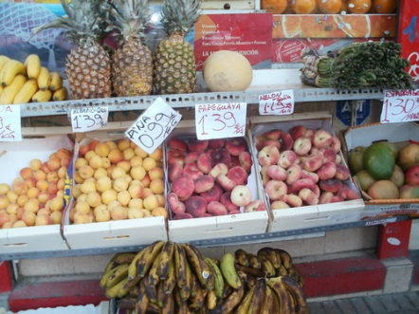 | Produce | - In this section we can find canned fruits, vegetables and soup.
2 | 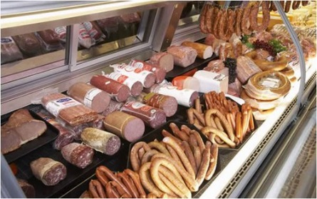 | Deli
4 | 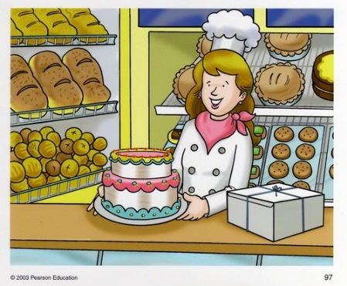 | Bakery
5 | 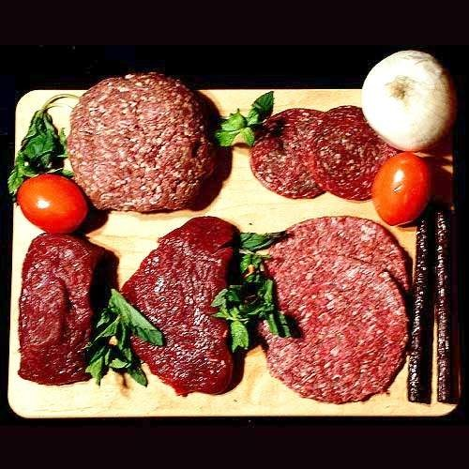 | Meat
6 | 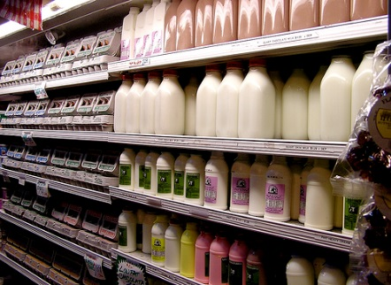 | Dairy
7 | 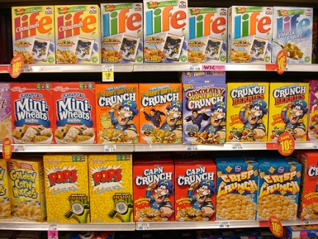 | Dried goods
8 | 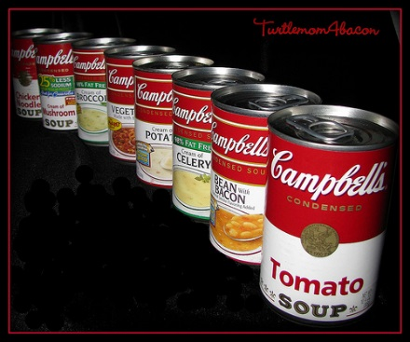 | Canned food
9 | 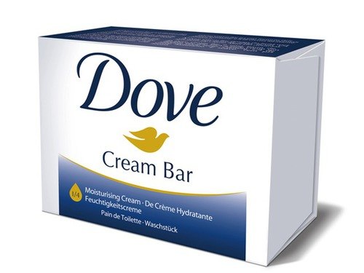 | Health and Beauty
10 | 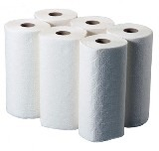 | Paper products
11 | 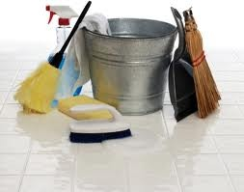 | Cleaning Supplies

Let’s Master it
Model Dialog
Situation: Jane is at the grocery store.
Clerk | : | May I help you?
Jane | : | Yes, please. I want to buy this box of cereal, but I couldn’t find the price tag. How much is this?
Clerk | : | It’s on the bottom here. It’s $2.
Jane | : | What about this loaf of bread? How much is it?
Clerk | : | It’s $ 1.
Jane | : | I need three boxes of cereal and two loaves of bread.
Clerk | : | Three boxes of cereal and two loaves of bread. Is there anything else, Ma’am?
Jane | : | No, that’s all.
Clerk | : | Okay. That will be $8.
Jane | : | $8? Here is ten dollars.
Clerk | : | Your change is two dollars. Here you are.
Jane | : | Thank you.
Clerk | : | You’re welcome. Have a nice day.
Activity 4.3. Dialog Comprehension
Answer the following questions about the dialog. (Jawablah pertanyaan-pertanyaan di bawah ini tentang dialog di atas).
- What did Jane buy?
- Which section should she go to buy the items she needed?
- How much did it all cost?
- How much did she pay?
- How much is the change?
Activity 4.4. Language expressions
Choose the best language expressions. (Pilihlah ungkapan yang paling tepat)
Dialog 1: Offering help
- A: Good morning, ma’am.
(A) I want to help you.
(B) May I help you?
(C) Tell me how to help you.

B: Yes, please. I’m looking for detergent. Where is the house cleaning section?
Dialog 2: Asking for price
- A: How much is this box of cereal?

B: (A) Do you need three boxes?
(B) It’s in the breakfast section.
(C) It’s $ 1.50.
Dialog 3: Expressing needs
- A: Do you have apples?
B: Yes, we do. How much do you need?
A: (A) Apples are very expensive.
(B) Yes, I need the apples.
(C) I need three kilos of apples.
Dialog 4: Asking the total cost
- A: Is there anything else ma’am?
B: No. That’s all.
A: Two boxes of spaghetti and one kilo of apples, right?
B: That’s right. (A) How much does it all cost?
(B) Can you give discount?
(C) How much is the discount?
A: It’s $ 4.45, ma’am.
Dialog 5: Giving the change
- A: Everything is $ 4.45?
B: Yes, ma’am.
A: Okay. Here is $ 10.
B: (A) Do you have a change for $ 5.55?
(B) Here is your change, ma’am: $5.55.
(C) Thank you for the change, ma’am.
A: Thanks.
Activity 4.5. Countable vs. Uncountable Nouns
Before you do the next activity, please note the following important pieces of information about the items we buy in grocery stores.
- Items we buy in the grocery stores can be categorized as Countable (that can physically be counted) and Uncountable (that cannot physically be counted).
Please look at the following list of items. Identify if they are countable (C) or uncountable (U).
No | Item | C | U | No | Item | C | U
1 | Sugar |  |  | 6 | Spaghetti
2 | Salt |  |  | 7 | Cereal
3 | Apple |  |  | 8 | Rice
4 | Orange |  |  | 9 | Tomato
5 | Banana |  |  | 10 | Cooking oil

Activity 4.6. Counting the uncountable items
We can make the uncountable nouns to be countable by counting the packaging (boxes, cups) or measurement (kilos, litters, gram). Choose the best answer in each number below. (Kita bisa menjadikan Uncountable nouns menjadi countable nouns dengan menghitung bungkus—kotak, gelas, mangkok--atau pengukurannya--Kilo, liter, gram. Pilih jawaban yang benar dari tiap nomor berikut.)
Dialog 1:
Buyer : Do you have any milk?
Clerk : Yes, ma’am.
- (A) How many do you need?
    - How much do you need?
    - So, you need something?
Buyer : I need two 2. (A) cartons of milk, please.
(B) loaves
(C) packages

Clerk : Okay, here you are ma’am.
Buyer : 3. (A) How much is it?
(B) How little is it?
(C) How many is it?

Clerk : It’s Rp. 30,000.
Buyer : Here you are.
Clerk : Here is your 4. (A) charge, Rp. 20,000 and here is the milk.
(B) chance
(C) change,

Dialog 2
Clerk : 5. (A) Can you help me, Sir?
(B) I can help you, please.
(B) Can I help you, Sir?
Buyer : Yes, please. 6. (A) I cannot find sugar
(B) Where should I find sugar?
(C) I need some sugar.
Clerk : How much do you need?
Buyer : 7. (A) Just Rp. 15,000, please. How much is it?
(B) Just one kilo of sugar, please.
(C) Just sugar, please.
Clerk : 8. (A) Sugar is really sweet, Sir.
(B) It’s sugar, Sir.
(C) It’s Rp. 15,000 per kilo, Sir.
Buyer : Okay. Here is Rp. 20,000.
Clerk : Thank you, Sir. Here is your change of Rp. 5,000.
Let’s Apply
Activity 4.7. Role Play
Student A is the clerk and student B is the buyer. Student B wants to buy a few items (choose the items below). Make a dialog between the clerk and the buyer.
(Student A adalah pegawai toko dan Student B adalah pembeli. Student B ingin membeli beberapa jenis makanan atau minuman di bawah ini (silakah dipilih). Buatlah dialog antara pegawai toko dan pembeli).
Foods  ___ loaf/loaves of bread  ___ kilo (kilos) of sugar, eggs, apples, oranges, pears, mangos  ___ can/cans of corn soup  ___ package/packages of ___  ___ box/boxes of ____ | Drinks  ___ bottle/bottles of milk, yoghurt, orange juice  ___ package/packages of tea, coffee  ___ cup/cups of ice cream

Sample dialog:
A: Good morning. May I help you ma’am/Sir?
B: Yes, I want to buy _____ and _____, please. How much is it?
A: The ____ is Rp. ____ and the _____ is Rp. ____. So, the total is Rp. _____.
B: Okay, here is Rp. ________.
A: Thank you. Here is your change, Ma’am/Sir, Rp. _____.
B: Thank you.
A: Is there anything else, ma’am/Sir?
B: No, thank you. That’s all.
A: All right. Have a good day!
Let’s Review
Activity 4.8. Discussion questions
Please discuss the following questions. (Diskusikan pertanyaan berikut dengan teman di kiri/kanan anda).
About the language expressions at a grocery shop:
- Can you give examples of 5 countable nouns?
- Can you give examples of 5 uncountable nouns?
- What do you say, when you want to ask for help?
- What do you say, when you want to offer help?
Let’s Take Note
Practical money and time saving tips for
Grocery Shopping

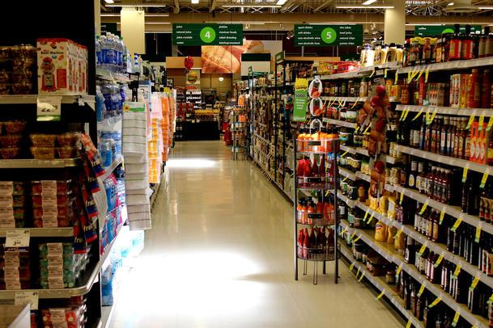 | Some people like buying their groceries fresh daily. Others prefer to buy their groceries weekly or monthly. There are also others who don’t have any specific plan or schedule to buy groceries. They just go grocery shopping when they feel like it. No matter what your grocery shopping habit is, you can read the following tips for money and time saving grocery shopping.
- Plan before shopping
Good planning will save you a lot of time and money. What do you prepare? First, prepare a list of items you want to buy. It is good to organize your list based on the food or drink categories or based on their display area. This will help you to shop more conveniently in a smooth manner from one section to the other. Then, check the prices of the items in the shopping catalogue (make a habit to grab the catalogue in the shop or check the prices on their websites). Pay attention to the items that are on discount on certain days of the week. Finally, when you shop, follow your plan, which means buy the items on your shopping list.

- Pick the best shopping time
Pick the best shopping time for you and the store. The best shopping time for you is when you are not in a hurry, and when you are not hungry. When you are not in a hurry and when the store is not too crowded, you can pick the best items and you will not forget any items on the list. Shopping when you are not hungry helps you to control yourselves from buying things that you don’t need.

So, be a smart shopper to save time and money. It’s easy to do. Just make plan before shopping and pick the best shopping time.

Discussion Questions:
- How often do you buy groceries? Do you buy your groceries daily, weekly or monthly?
- What is your most favorite store to buy your groceries? Tell us about this store and why you like shopping here.
- Do you think it is important to make plans before shopping? What about you? Do you make plans before shopping?
- When is the best time for you to shop?
- Do you have any other shopping tips that you can share to save time and money?

