UNIT 10
Locating things and giving directions

Target Skills  (Keterampilan Utama) | Speaking and Writing (Berbicara and menulis)
Supporting Skills  (Keterampilan Pendukung) | Listening and reading (Mendengar dan membaca)
Learning Objectives  (Tujuan Pembelajaran) | You will be able to: (Anda akan mampu melakukan hal-hal berikut)  - Use prepositions of place to locate things  - Give simple directions to a place.
Learning Activities  (Kegiatan Pembelajaran) | - Start: Places around us  - Master:  - Prepositions of place  - Giving directions  - Model dialog  - Apply:  - Locating things  - Giving directions  - Review: Game  - Take note: Asking for help

Let’s Start
Activity 10.1. Places around us
Do you know what these places are? Choose the best answers. (Tahukah anda tempat-tempat di bawah ini? Pilihlah jawaban yang tepat.)

- (A. School B. Post office C. Police station) | - (A. Apartment B. Doctor C. Hospital)
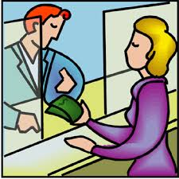
- (A. Bank B. Library C. Gift shop) | - (A. Supermarket B. Pharmacy C. Bank)

These are the places people go to. Sometimes, when you are in another town, you don’t know where these places are, so you can ask questions. Today, we are going to learn how to ask for and give simple directions to go to a place.

Let’s Master it
Locating things
A simple way to give directions to a place is by showing its location using prepositions of place. Look at the pictures below. (Cara sederhana untuk memberi arah adalah dengan menggunakan “prepositions of place”. Lihat gambar-gambar berikut).
beside
(di dalam) (pada) (diatas) (dekat) (di sebelah)
(di depan) (di belakang) (di antara/ditengah) (di seberang)
Activity 10.2. Locating things
Look at the picture below and ask and answer questions in a simple dialog with a friend. Look at the example. (Lihat gambar di bawah ini dan jawab pertanyaan-pertanyaannya dalam dialog sederhana dengan seorang teman. Perhatikan contoh)
For example:
(Hospital) A: Excuse me, where is the hospital?
B: It is on Pine Street, between the library and barbershop.
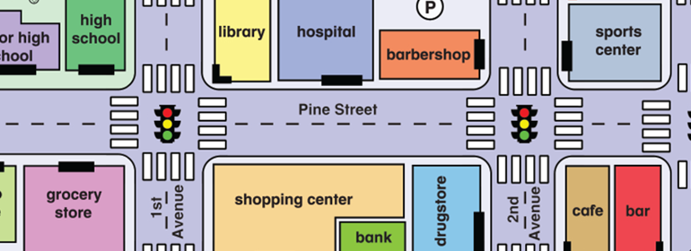
- (High school) A: ______________________________________

B: ______________________________________

- (Shopping center) A: ______________________________________

B: ______________________________________

- (Grocery store) A: ______________________________________

B: ______________________________________

- (Café) A: ______________________________________

B: ______________________________________

- (Library) A: ______________________________________

B: ______________________________________

- (Drugstore) A: ______________________________________

B: ______________________________________

- (Bank) A: ______________________________________

B: ______________________________________

- (Sports center) A: ______________________________________

B: ______________________________________

- (Barbershop) A: ______________________________________

B: ______________________________________

- (Bar) A: ______________________________________

B: ______________________________________

Giving Directions
Besides using prepositions of place (in, on, between, behind, in front of, next to/beside, near, opposite), we can also give directions by using the following phrases. (Selain menggunakan ‘PREPOISITIONS OF PLACE’ (in, on, between, behind, in front of, next to/beside, near, opposite), kita juga bisa memberi arah dengan menggunakan ungkapan-ungkapan berikut).
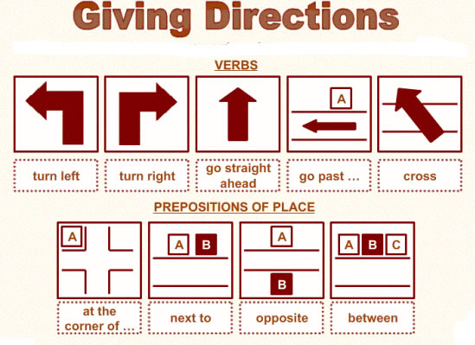

Activity 10.3. Giving directions
Look at the map below and ask and answer questions in a simple dialog with a friend. Look at the example. (Lihat gambar peta di bawah ini coba berikan petunjuk arah untuk pergi dari suatu tempat ke tempat lain. Lihat contoh).
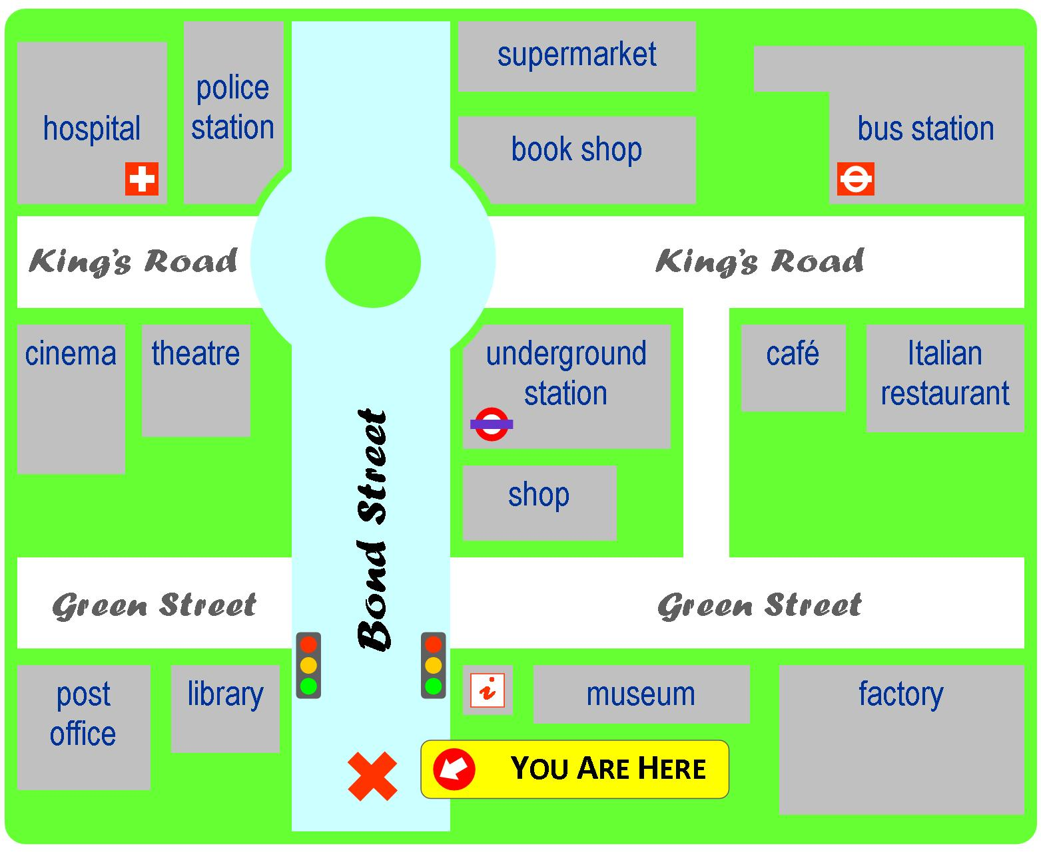
(From where you are to bus station)
Go straight on Bond Street. Turn right to King’s road. The bus station is in the corner, in front of the Italian restaurant.
- (From the Cinema to the museum)

- (From the post office to the police station)

- (From the bus station to the post office)

- (From where you are to the hospital)

- (From the bus station to the shop)

Let’s Apply
Activity 10.4. Answering questions
Study the following the map. Then, answer the following questions. (Pelajari peta di bawah ini. Kemudian, jawab pertanyaan-pertanyaan di bawah ini)
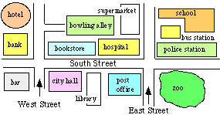

1 | Where is the Bus Station?
2 | Where is the Book Store?
3 | Where is the Zoo?
4 | How do I get to the Zoo from the Hotel?
5 | How do I get to the supermarket from the hotel?

Activity 10.5. Choosing the right expressions
Study the following the map in the previous and the model dialog below. Then, make choose the right answer in each number. (Pelajari peta di bawah ini. Kemudian, pilih jawaban yang paling tepat di tiap nomor.)
Model Dialog.
Visitor : Excuse me, Sir.

Police officer : Good afternoon. 1. A. Can you help me?
- Can I help you?
- We can help you?

Visitor : I want to go to the zoo from this bank.
2. A. How do you know?
B. How are you?
C. How do I get there?

Police officer : It’s simple. Exit the bank on South Street. Go straight ahead.
Cross two intersections.
The Zoo is 3. A. opposite the police station, on South street.
B. beside
C. between

Visitor : Is it on the left or right?
Police officer : It is 4. A. on the left side
B. on the right side.
C. on both sides.

Visitor : Okay. Thank you, Sir.
Police officer : 5. A. You’re okay.
B. You’re fine.
C. You’re welcome.

Activity 10.6. Performing a dialog
Study the following the map in. Then, make a dialog about locating things and giving direction with a friend. (Pelajari peta di bawah ini. Lalu, role-play-kan dialog dengan teman anda tentang memberi petunjuk arah).
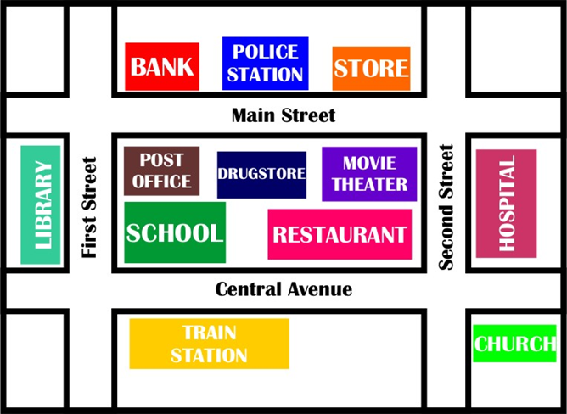
Let’s Review
Activity 10.7. Guessing Game
Think about a nearby place to go. Do not mention the name of the place. Give directions from where you are now to this place. Let the class guess what place it is. You can also give clues. (Pikirkan sebuah tempat yang dekat dari sini. Jangan sebutkan nama tempat tersebut. Beri petunjuk arah untuk pergi ke tempat ini dari sini. Teman-teman di kelas anda akan menebak tempat tersebut. Anda bisa juga memberi petunjuk terkait jenis tempat tersebut).

For example:
This is a hotel. From this place, you turn left to _____ Street. Go straight ahead around 1 km. The place is on the right side of the street, between a fastfood restaurant and a housing complex. What place is it?
Write your directions here! (Tuliskan petunjuk anda disini)

Let’s Take Note
Giving directions
Everyone has or will give directions to someone at some point. Whether you’re telling someone how to get to your house or you’re instructing a stranger about how to get to a local museum, you should know how to give good directions. Here are some tips to give clear directions.
- Communicate effectively: To do this, you need to speak slowly and clearly. If necessary, you can also repeat the information.
- Give the distance: Tell the person the distance between one point to the other (for example: meters, kilometers)
- Give the time: Besides distance, you can try to give the time to get there.
- Indicate Landmarks: Use famous landmarks (such as historic buildings, traffic signs, and monuments) to help you locate the place.
- Draw a map: If you have problem giving the directions, draw a simple map.
Activity 10.8. Discussion Questions
Read the article and answer the questions. Then, discuss the answers with your friend. (Bacalah artikel and jawab pertanyaan-pertanyaan di bawah ini. Kemudian, diskusikan jawaban anda dengan seorang teman).
- What should we do to communicate effectively?
- What metric system do we use in Indonesia to give information about distance from one point to the other?
- What are some famous landmarks near here?

