
The Science of Sleepy Teenagers

11.2k

763

0
School schedules make them grouchy, impulsive, and humorless.
By Russell Foster

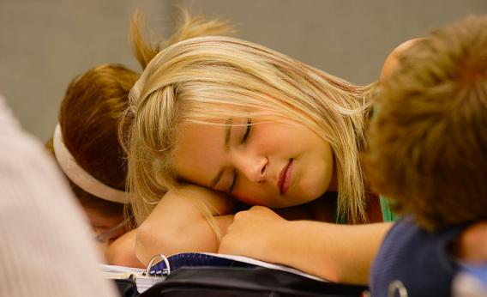
There's a legitimate reason why teenagers fall asleep in class.
Photo by Design Pics/Thinkstock Photos
"Making teens start school in the morning is ‘cruel,’ brain doctor claims." So declared a British newspaper headline in 2007 after a talk I gave at an academic conference. One disbelieving reader responded: "This man sounds brain-dead."

That was a typical reaction to work I was reporting at the time on teenage sleep patterns and their effect on performance at school. Six years on, there is growing acceptance that the structure of the academic day needs to take account of adolescent sleep patterns. The latest school to adopt a later start time is the UCL Academy in London; others are considering following suit.
So what are the facts about teenage slumber, and how should society adjust to these needs?
The biology of human sleep timing, like that of other mammals, changes as we age. This has been shown in many studies. As puberty begins, bedtimes and waking times get later. This trend continues until 19.5 years in women and 21 in men. Then it reverses. At 55 we wake at about the time we woke prior to puberty. On average this is two hours earlier than adolescents. This means that for a teenager, a 7 a.m. alarm call is the equivalent of a 5 a.m. start for people in their 50s.
Precisely why this is so is unclear, but the shifts correlate with hormonal changes at puberty and the decline in those hormones as we age.
However, biology is only part of the problem. Additional factors include a more relaxed attitude to bedtimes by parents, a general disregard for the importance of sleep, and access to TVs, DVDs, PCs, gaming devices, cellphones, and so on, all of which promote alertness and eat into time available for sleep.
The amount of sleep teenagers get varies between countries, geographic region, and social class, but all studies show they are going to bed later and not getting as much sleep as they need because of early school starts.
Mary Carskadon at Brown University, who is a pioneer in the area of adolescent sleep, has shown that teenagers need about nine hours a night to maintain full alertness and academic performance. My own recent observations at a U.K. school in Liverpool suggested many were getting just five hours on a school night. Unsurprisingly, teachers reported students dozing in class.
Evidence that sleep is important is overwhelming. Elegant research has demonstrated its critical role in memory consolidation and our ability to generate innovative solutions to complex problems. Sleep disruption increases the level of the stress hormone cortisol. Impulsive behaviors, lack of empathy, sense of humor, and mood are similarly affected.
All in all, a tired adolescent is a grumpy, moody, insensitive, angry, and stressed one. Perhaps less obviously, sleep loss is associated with metabolic changes. Research has shown that blood-glucose regulation was greatly impaired in young men who slept only four hours on six consecutive nights, with their insulin levels comparable to the early stages of diabetes.
Similar studies have shown higher levels of the hormone ghrelin, which promotes hunger, and lower levels of leptin, which creates a sense of feeling full. The suggestion is that long-term sleep deprivation might be an important factor in predisposing people to conditions such as diabetes, obesity, and hypertension.
Adolescents are increasingly using stimulants to compensate for sleep loss, and caffeinated and/or sugary drinks are the usual choice. The half-life of caffeine is five to nine hours. So a caffeinated drink late in the day delays sleep at night. Tiredness also increases the likelihood of taking up smoking.
Collectively, a day of caffeine and nicotine consumption, the biological tendency for delayed sleep, and the increased alertness promoted by computer or cellphone use generates what Carskadon calls a perfect storm for delayed sleep in teenagers.
In the United States, the observation that teenagers have biologically delayed sleep patterns compared with adults prompted several schools to put back the start of the school day. An analysis of the impact by Kyla Wahlstrom at the University of Minnesota found that academic performance was enhanced, as was attendance. Sleeping in class declined, as did self-reported depression.
In the U.K., Monkseaton High School near Newcastle instituted a 10 a.m. start in 2009 and saw an uptick in academic performance.
However, a later start by itself is not enough. Society in general and teenagers in particular must start to take sleep seriously.
Sleep is not a luxury or an indulgence but a fundamental biological need, enhancing creativity, productivity, mood, and the ability to interact with others.
If you are dependent upon an alarm clock or parent to get you out of bed; if you take a long time to wake up; if you feel sleepy and irritable during the day; if your behavior is overly impulsive, it means you are probably not getting enough sleep. Take control. Ensure the bedroom is a place that promotes sleep—dark and not too warm—don't text, use a computer, or watch TV for at least half an hour before trying to sleep, and avoid bright lights. Try not to nap during the day and seek out natural light in the morning to adjust the body clock and sleep patterns to an earlier time. Avoid caffeinated drinks after lunch.
It is my strongly held view, based upon the evidence, that the efforts of dedicated teachers and the money spent on school facilities will have a greater impact, and education will be more rewarding when, collectively, teenagers, parents, teachers, and school governors start to take sleep seriously. In the universal language of school reports: We must do better.
This article originally appeared in New Scientist.

Russell Foster is professor of circadian neuroscience, chair of the Nuffield Laboratory of Ophthalmology, and director of the Sleep and Circadian Neuroscience Institute, University of Oxford. He co-wrote Sleep: A Very Short Introduction.

Source: http://www.slate.com/articles/health_and_science/new_scientist/2013/04/teenage_sleep_patterns_why_school_should_start_later.single.html

