Session 6
This is My Family:
Talking about Core and Extended Family

Target Skills  (Keterampilan Utama) | Speaking and Writing (Berbicara dan menulis)
Supporting Skills  (Keterampilan Pendukung) | Listening and reading (Mendengar dan membaca)
Learning Objectives  (Tujuan Pembelajaran) | You will be able to: (Anda akan mampu melakukan hal-hal berikut)  - Mention members of core family. (Menyebutkan anggota keluarga inti).  - Introduce members of core family: Name, age, occupation, family relationship. (Memperkenalkan anggota keluarga inti: nama, usia, pekerjaan dan hubungan keluarga)  - Mention members of extended family: Name, age, occupation, family relationship. (Menyebutkan anggota keluarga besar: nama, usia, pekerjaan, dan hubungan keluarga)
Learning Activities  (Kegiatan Pembelajaran) | - Start:  - Different types of family – matching pictures and sentences  - Master it:  - Family Tree – Timmy and His Family: Answering Questions  - Apply:  - My big family—Joshua and her family: choosing the best answer  - Drawing Group’s family tree  - Introducing group’s family tree  - Writing about group’s family tree  - Review: Talking about family photo  - Take note: Talking about the meaning of family

Let’s Start
Activity 5.1: Different types of family
Look at the two pictures and read the Sentences in the Sentence Bank. Match the sentences with the Pictures by writing down each sentence in the box next to the related picture. (Perhatikan dua gambar berikut, dan pelajari kalimat-kalimat di bank kalimat. Pasangkan kalimat dengan gambar terkait dengan menuliskannya di kotak yang tersedia disamping gambar).
Picture 1: Core Family  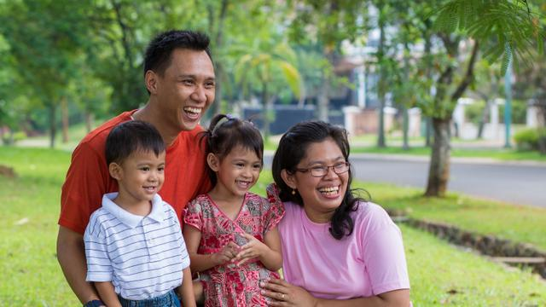 | Sentences related to Picture 1  - _______________  - _______________  - _______________  - _______________  - _______________

Picture 2: Extended Family  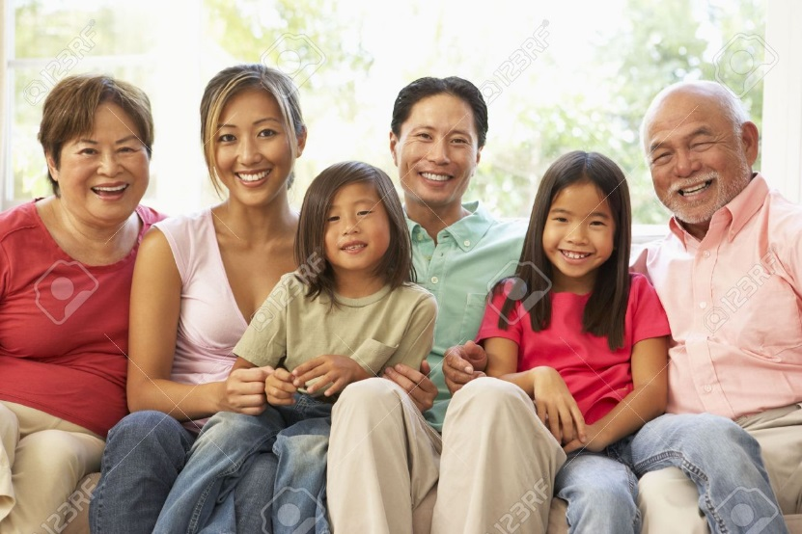 | Sentences related to Picture 2  - _______________  - _______________  - _______________  - _______________  - _______________

Sentence Bank:
- The family have two daughters
- Here is a picture of a father, mother, grandfather, grandmother, and two children
- There is green grass in the background
- They are in the park
- Here is a picture of a father, mother, two children
- The family have one daughter and one son
- They are all sitting down
- The mother is wearing glasses
- They are probably at home
- The girls are wearing jeans

Let’s Master it
Activity 5.2: Tim and His Family
EXPLORE the family tree below. Then, answer the questions. (Eksplorasi pohon keluarga berikut. Kemudian, jawablah pertanyaan terkait).
TIMMY AND HIS FAMILY
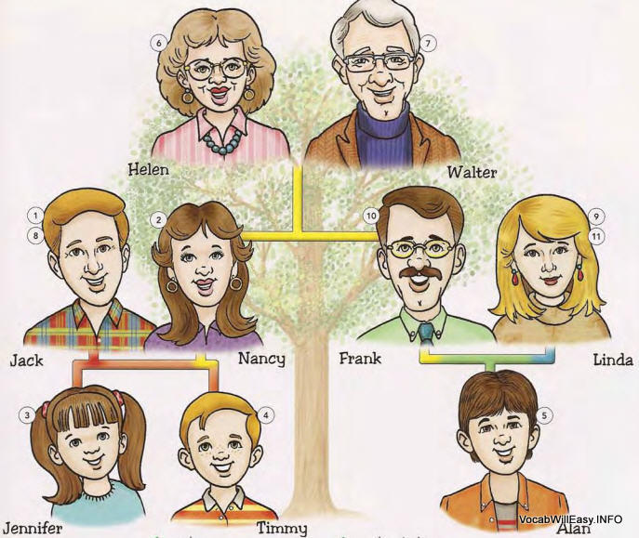
- Who is Timmy’s father? _____ is Timmy’s father.
- Who is Timmy’s mother? _____ is Timmy’s mother.
- Who is Timmy’s sister? _____ is Timmy’s sister.
- Who is Timmy’s uncle? _____ is Timmy’s uncle.
- Who is Timmy’s aunt? _____ is Timmy’s aunt.
- Who is Timmy’s cousin? _____ is Timmy’s cousin.
- Who is Timmy’s grandfather? _____ is Timmy’s grandfather.
- Who is Timmy’s grandmother? _____ is Timmy’s grandmother.
Let’s Apply
Activity 5.3: Joshua and His Big Family
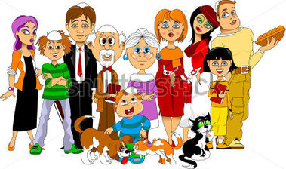
You have just learned about family members. Now, study Joshua’s big family’s picture and family tree, then circle the best answer in each number below the family tree. (Anda baru saja belajar tentang anggota keluarga. Sekarang, perhatikan foto keluarga besar Joshua, lalu lingkari jawaban yang paling tepat di tiap nomor di bawah pohon keluarga).
Joshua’s Family Tree
Sarah Smith
Paul Smith

Janet
Bob
Joshua
Maria
Kevin
Bill
Susan
Lucy

Joshua’s core family
- Janet is Joshua’s (father, mother).
- Bob is Joshua’s (father, mother).
- Janet and Bob are Joshua’s (parents, children).
Other core family relationships
- Bob and Bill are the (sons, daughters) of Paul and Sarah.
- Susan is the (son, daughter) of Paul and Sarah.
- Bill and Lucy has two (children, cousins).
Joshua’s extended family
- Paul is Joshua’s (grandfather, grandmother)
- Sarah is Joshua’s (grandfather, grandmother)
- Susan is Joshua’s (uncle, aunt)
- Bill is Joshua’s (uncle, aunt)
- Maria and Kevin are Joshua’s (children, cousins)
- Maria is Susan’s (niece, nephew)
- Kevin is Susan’s (niece, nephew)
- Lucy is Bob’s (brother in law, sister in law)
- Bill is Janet’s (brother in law, sister in law)
- Joshua, Maria and Kevin are the (grandchildren, grandparents) of Paul and Sarah.
Activity 5.4: MY FAMILY TREE
- Draw a family tree. (Gambarkan pohon keluarga)
- Decide the family relationships among the members of the family within each family tree. (Tentukan hubungan keluarga antar anggota keluarga dalam pohon keluarga)
- Explain the family tree in terms of family relationships orally. (Jelaskan secara lisan dengan menggunakan pohon keluarga yang sudah dilengkapi).

Draw a family tree
_________ Family Tree
___________
___________

________
________

________

________

________

________

________

________

Activity 5.5: Writing about my big family
Now, individually, write a short paragraph of around 10 sentences to introduce the family members in the family tree. You don’t need to introduce everyone, just some of the members. (Sekarang, secara perorangan, tuliskan paragraph pendek sekitar 10 kalimat untuk memperkenalkan anggota keluarga dalam pohon keluarga tersebut. Anda tidak perlu memperkenalkan setiap anggota—beberapa anggota keluarga saja sudah cukup – 3 sampai 5 anggota keluarga)

Let’s Review
Activity 5.6: Reflecting on a family photo
Find a photo of you and any family members. Reflect and talk about the people in the photo. (Carilah foto anda dan anggota keluarga. Pikirkan apa yang akan anda ceritakan tentang mereka, lalu tuliskan dan ceritakan).
- Who is it?
- What’s his/her name?
- How is he/she related to you?
- When was this photo taken?
- What was the event?
- Who else attended the event?
- What is memorable about this event/photo?
Let’s Take Note
Meaning of family
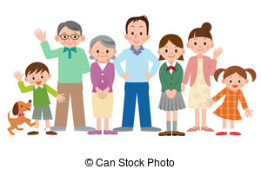
According to Michelle Blessing, FAMILY is a single word with many different meanings. Therefore, people have many ways of defining a family and what being a part of a family means to them. Family differ in terms of economic, cultural, biological, social and many other facets. However, what every family has in common is that the people who call it a family are making clear that those people are IMPORTANT in some way to the person calling them his family. So, it’s not about blood-related family. It’s more about love-related family. People in a group you call a family feel that they are important part of their lives. Love binds their relationship.
To read more about family, visit: http://family.lovetoknow.com/about-family-values/meaning-family
Activity 5.7. My family is special
Think about why your family is special. Write the answers below under the column entitled “My Reasons”. Then, if possible, share it with someone or your learning partner.(Pikirkan mengapa keluarga anda sangat istimewa. Tuliskan jawabannya di bawah kolom berjudul “My Reasons” (alasan saya). Setelah itu, dimana memungkinkan, bagikan informasi ini kepada orang lain atau rekan belajar anda).
Question | My reasons
Why is my family special? | Reason 1:  Reason 2:  Reason 3:

