ASSIGNMENT FOR WEEK 2
- VOCABULARY ACTIVITY
Activity 1: Signs in the hospital
Directions: Here are some signs that you can find in a hospital. Below the signs you will read the labels. Match the signs and the labels
Picture 1 | Picture 2 |  | Picture 3
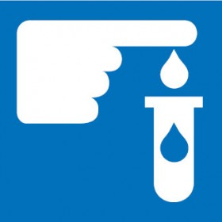 | 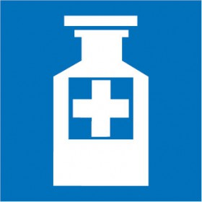 |  | 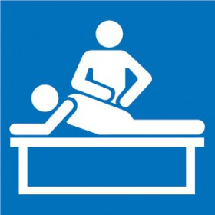
Picture 4 | Picture 5 |  | Picture 6
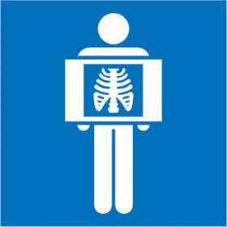 | 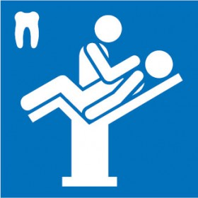
Picture 7 | Picture 8 |  | Picture 9
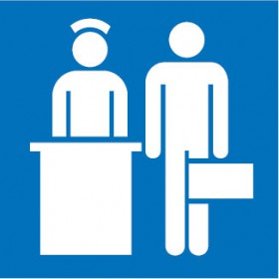
- Pathology symbol (Picture: ___)  - X-ray symbol(Picture: ___)  - Occupational therapy symbol (Picture: ___)  - Dental symbol (Picture: ___)  - Physiotherapy symbol (Picture: ___) |  | - Cardiac protected electrical symbol (Picture: ___)  - Outpatient symbol (Picture: ___)  - Admission symbol (Picture: ___)  - Pharmacy symbol (Picture: ___)
Source: http://www.seton.net.au/signs-labels/information-signs/hospital-nursing-home-signs.html?p=3
Activity 2: Hospital wards and departments
There are many hospital departments, staffed by a wide variety of healthcare professionals, with some crossover between departments.
Below is a list of the main departments you'll come across when you visit a hospital. Some of these units work very closely together, and may even be combined into one larger department. The name of each department is scrambled. Can you rearrange the letters to form the name of each department? Number 1 has been given as an example.
No | Department/Ward | Descriptions
1 | CIADCETN & YEEGRMENC  ________________ &  _________________  ACCIDENT AND EMERGENCY (A&E) | - This department (sometimes called Casualty) is where you're likely to be taken if you've called an ambulance in an emergency.  - It's also where you should come if you've had an accident, but can make your own way to hospital.  - These departments operate 24 hours a day, every day and are staffed and equipped to deal with all emergencies.
2 | UTPAOTITEN  ______________ | This department is for patients with short visit to hospital that lasts no more than a day.
3 | IATIEPNTN  ______________ | This part of the hospital is for patients with visit that requires at least one night's stay on a ward.
4 | RCADILYOGO  ______________ | This department provides medical care to patients who have problems with their heart or circulation. It treats people on an inpatient and outpatient basis.
5 | CALINCYHPA  ______________ | Chaplains promote the spiritual and pastoral wellbeing of patients, relatives and staff.  They are available to all members of staff for confidential counsel and support irrespective of religion or race. A hospital chapel is also usually available.
6 | ACLRITIC CARE  ______________ | Sometimes called intensive care, this unit is for the most seriously ill patients.  Patients requiring intensive care are often transferred from other hospitals or from other departments in the same hospital.
7 | NDIACOGSTI IMAGING  ______________ | Formerly known as X-ray, this department provides a full range of diagnostic imaging services including: general radiography (X-ray scans), scans for A&E, mammography (breast scans), ultrasound scans, angiography (X-ray of blood vessels), interventional radiology (minimally invasive procedures, eg to treat narrowed arteries), CT scanning (scans that show cross sections of the body) and MRI scanning (3D scans using magnetic and radio waves).
8 | AER, NSOE AND HRTOAT (ENT)  ______________ | The department provides care for patients with a variety of problems, including:  - general ear, nose and throat diseases  - neck lumps  - cancers of the head and neck area  - balance and hearing disorders  - snoring and sleep apnoea  - ENT allergy problems  - voice disorders.
9 | REIACRIGT  department  ______________ | Led by consultant physicians specializing in geriatric medicine, this department looks after a wide range of problems associated with the elderly.  It provides a range of services such as home visits, day hospitals and outpatient clinics. The department often has close links with other community services for the elderly.
10 | EGNREAL RGUERYS  ______________ | The ward covers a wide range of surgery and includes: day surgery, thyroid surgery, kidney transplants, colon surgery, laparoscopic cholecystectomy (gallbladder removal), endoscopy, breast surgery.

Source: http://www.netdoctor.co.uk/health-services/nhs/a4502/a-to-z-of-hospital-departments/

Activity 3: Video Showing

VIDEO SHOWING: I AM A NURSE
Click the link below to watch the video.
- https://www.youtube.com/watch?v=bVZ4MNofC-c

Directions: Watch the video and answer the following questions.

- What is the name of the patient?
- Jim
- John
- Joe

- What does the nurse keep labeling herself as a nurse?
- I’m a professional nurse
- I’m just a nurse
- I’m a new nurse

- Why does the patient think that the nurse is more than just a nurse?
- The nurse takes care of many patients
- The nurse is just doing her routine jobs
- The nurse is a special nurse who cares for him

- What does the patient inspire the nurse to do in the future?
- To treat patients as persons, not just room numbers
- To meet with different types of patients in the hospital
- To change medication of patients when asked

- What does the patient remind the nurse about the job of a nurse?
- A nurse works in a hospital
- A nurse is a life saver
- A nurse is just a nurse

Activity 4: Dialog Script
Partner(s) : ____________________________________________________
Dialog Script :

